Leg Work Application Prototype Report

Seng 310

Human Computer Interaction

Arthur Wang

Andy Xu

Bill Wang

Erik Yu

Lucas Li

**Introduction:**

This report depicts the processes involved in Leg Work’s app development for optimal viewing capability regardless of screen size of the mobile devices it is viewed on. The app mainly is to provide peer-to-peer delivery and hitch-ride service in city. It is a platform that could save both the end’s time and the money. Some people like to trade time for money, and someone likes to do it in the opposite way. So our users have options to either become consignor or trustee by using this app. The report also points to how our team made It “interactive” to the users.

**Implementation Choices:**

The software we used to create prototype is Adobe XD, which is perfect for designing and prototyping user experience for mobile apps. The first interface you will see is the login page with “Signup” and “Forget Password” options. And of course, we designed and linked different interfaces from the top to bottom based on previous mock-up’s contents.

**Prototype Description:**

Once the user logs in, he can choose to be the consignor(post the job) or trustee(find the job).(Figure 1 ) If the user choose to be the consignor, the app will switch to the consignor interface. If it is a delivery job, which will let the user input the job’s details such as expected time, destination’s name, and ordering details.(Figure 2) If it is a hitch job, which will let the user input the start point and end point instead(Figure 3). The user has a grocery list or food menu to select from, so there is no need to type in those information by hands(Figure 4). After items has been selected, the user has two options for next step. Either waiting for trust at selected area to take your order, or assign your job to certain trust(Figure 5). The consignor will be able to see the available trusts with their ratings at current location. The last step to is place the order and pre-authorize the order balance with credit card or Paypal. (Figure 6)

On the trustee sides, the user has initiative to find a task if they choose not to wait. By doing so, the user can choose types of work they wish to do based on their current location(Figure 7). Users can change their searching radius to show more fitted job. And have the option to turn on notification of updated work.(Figure 8) After the user read the job/ reward details, they can take the order and start their trustee job. (Figure 9)If it is a take-out food or grocery delivery, the trustee needs to use their own money to pay at store, and then receives the money plus reward from the app. During the whole process, legwork is not only a platform, it is also a middle man to protect both ends.

After the task completed, the consignor can rate the trustee or submit a complaint application on app, which will request consignor to upload photo evidences/ chat history and descriptions. Our staff will verify it, and punish the trustee/ Making refund accordingly. (Figure 10)

Figure 1: 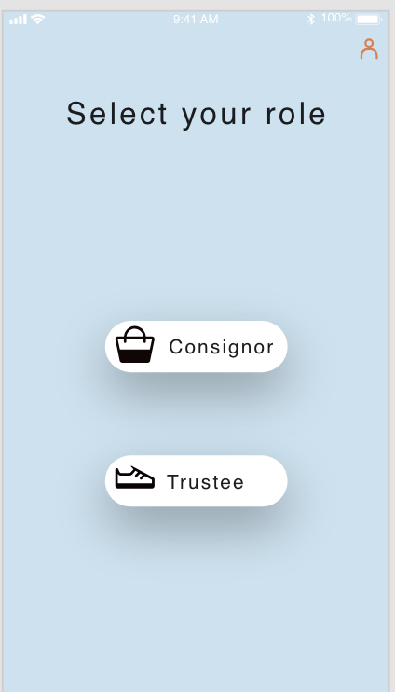 Figure 2: 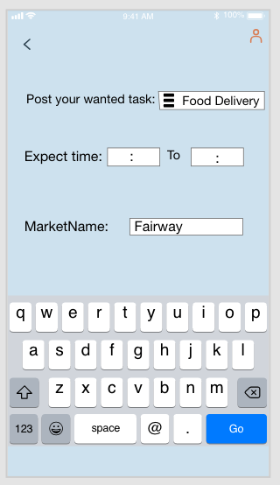 Figure 3: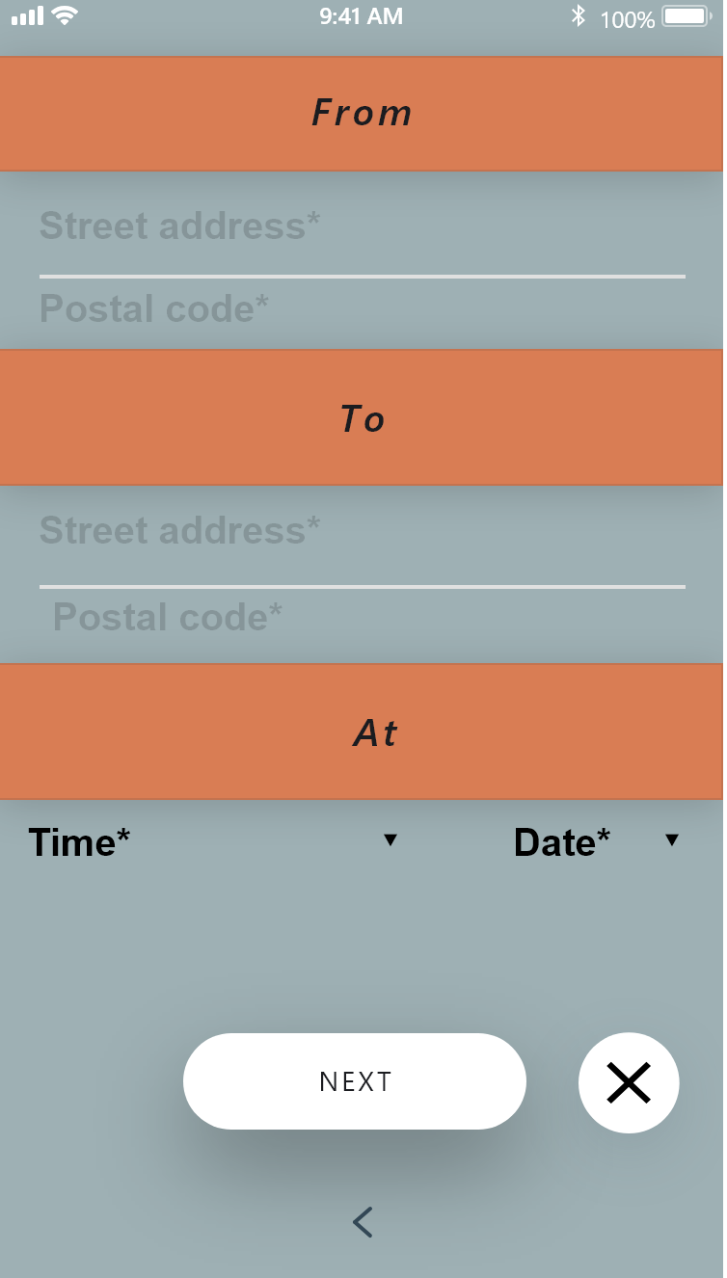 Figure4: 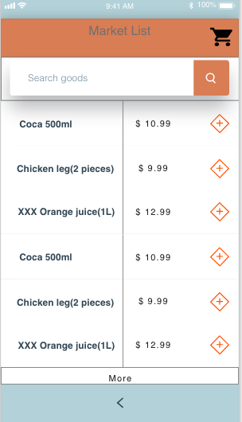

Figure 5 :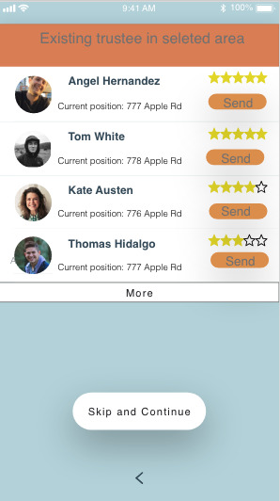 Figure 6: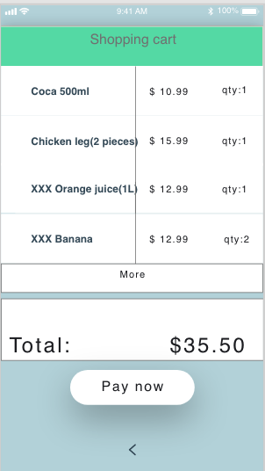 Figure 7: 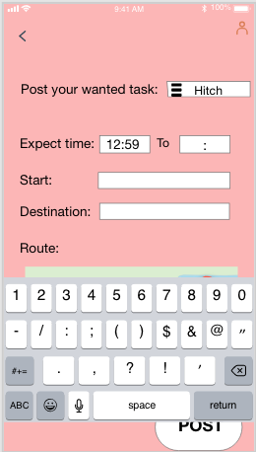 Figure 8: 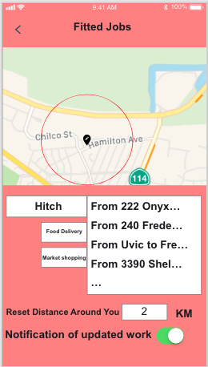

Figure9 : 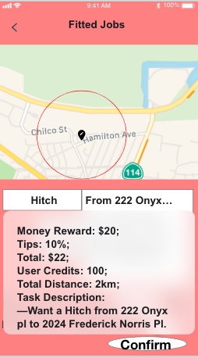 Figure10: 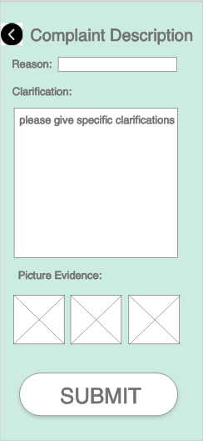

**Limitation:**

The time and our insufficient knowledge about web application development limited our high fidelity prototype and there by our project. No one in our group has developed a web application from scratch before, and it was therefore a steep learning curve for the web app development work. We learned and tested many different web app frameworks in order to choose the ones that fit to our project, so behind the prototype , there were many hours invested . The project setting did also limit our possibilities of conducting usability testing, In addition, the time was limited.

If we had more time and more competence and experience on the development for web application, we would test on more real-life situation. We have following limitations on this prototype:

1. Since we need the trustees to use their own money to pay for consignor’s good in advance, it will affect trustee’s user experiences, raising their safety concern. Especially if the trustee has insufficient fund.
2. The trustee are not able to take multiple jobs at one time in this app. If there are more than one consignors asking for McDonald on Shelbourne St. It would be more efficient to let one trustee at that place to deliver all orders at ones.
3. The app asks trustee to pay tip in advance, but it does not really make sense for doing that if the user have not receive services yet. But in order to minimize the fund transaction problem, we do not have alternative choices yet.

**Conclusion**

It is hard to conclude anything valid before we test this app in the real world. We think that our app features are very continent but not considerate. We need more user tests to build a reliable product. But we know that the potential users are demanding this type of app. This gives us hope that we are on the right track.

**Contributors**:

Prototype design: Arthur Wang, Andy Xu, Bill Wang, Erik Yu

HTML page design: Arthur Wang, Andy Xu, Bill Wang, Erik Yu, Lucas Li

Report: Lucas Li

References:

1. <https://www.google.ca/search?q=iphone+album&hl=en&source=lnms&tbm=isch&sa=X&ved=0ahUKEwiw_JGc3f3gAhVDLX0KHZBcBv4Q_AUIDigB&biw=1655&bih=805#imgrc=h1k7TR7a0Txy8M>
2. <https://www.xdguru.com/adobe-xd-ui-kits/>